After build back end microservices, start to build front end react

Project tree

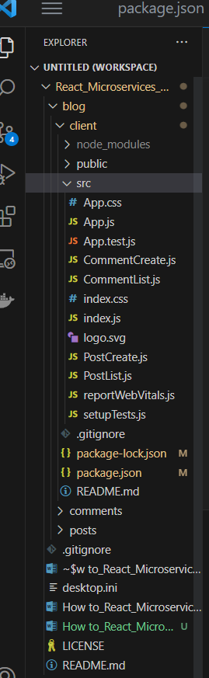

Delecte client/ src/ *

Return:

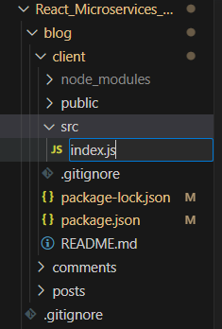

Create blog/ client/ PostCreate.js component

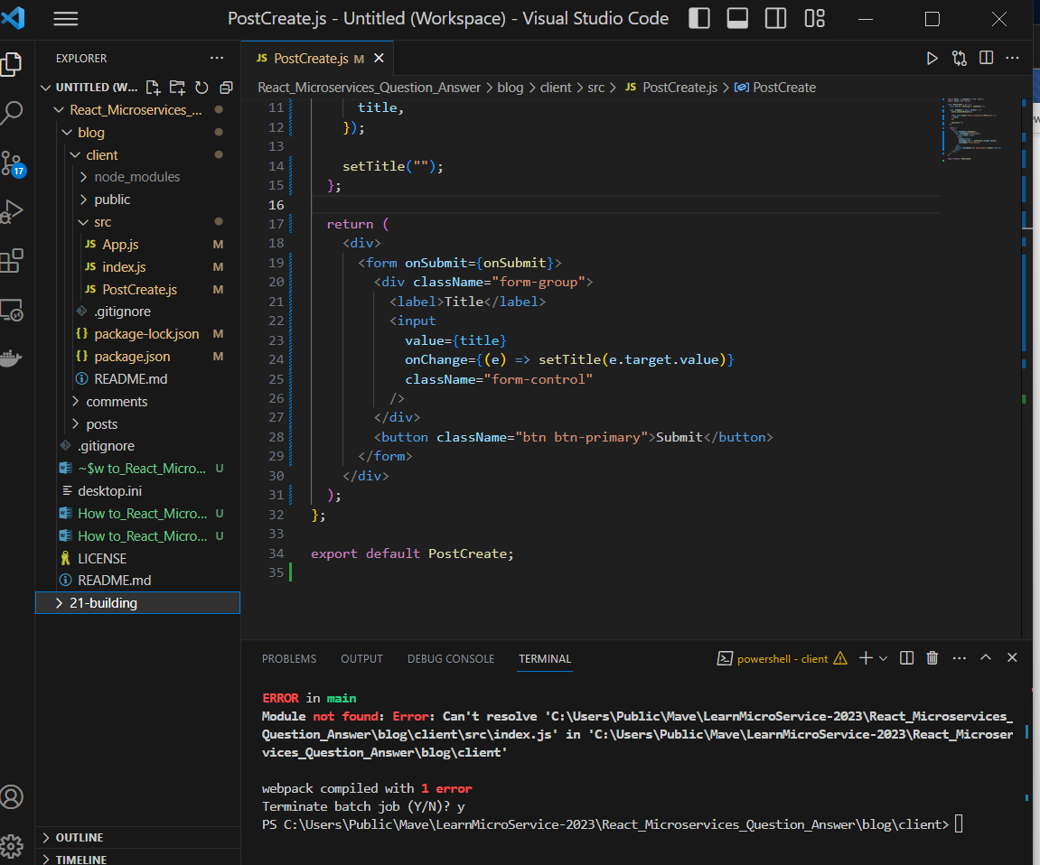

( IMPORTANT: axios has been install)

Create: src/ App.js

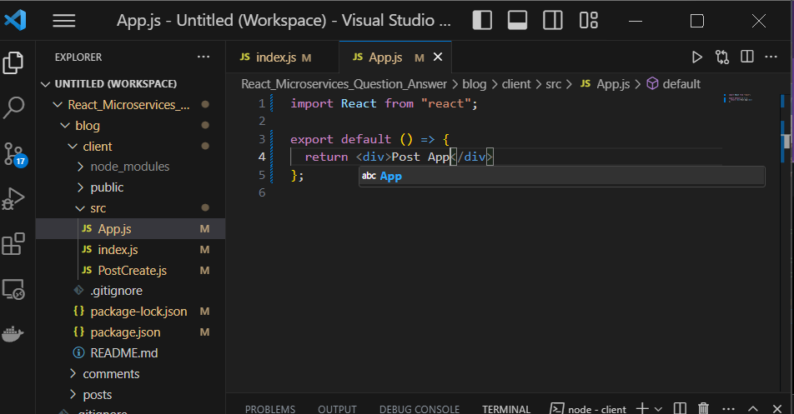

Create. Src/ index.js

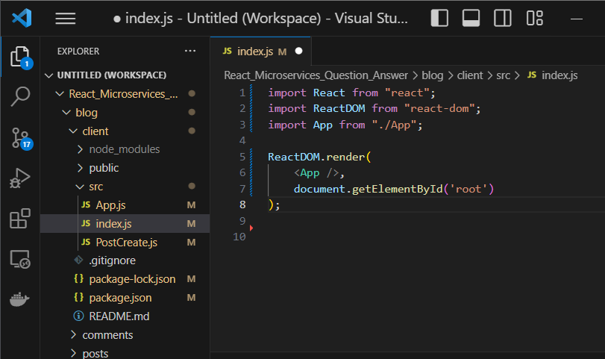

IMPORTANT:

getElementById(‘root’), root element is from public/ index.html

below

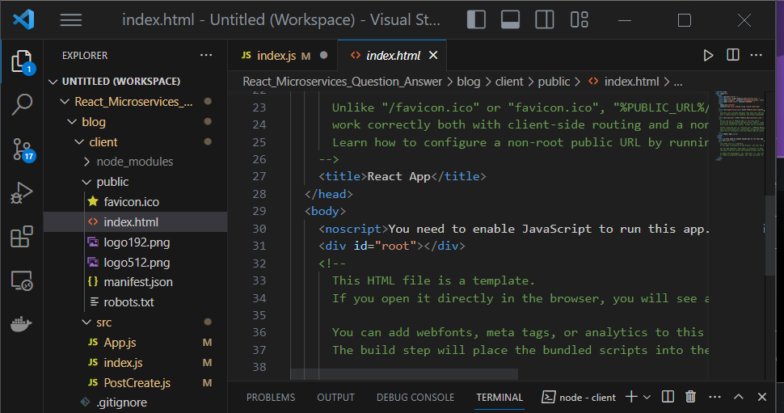

Then,

Blog/client/ npm start

Open browser

Return

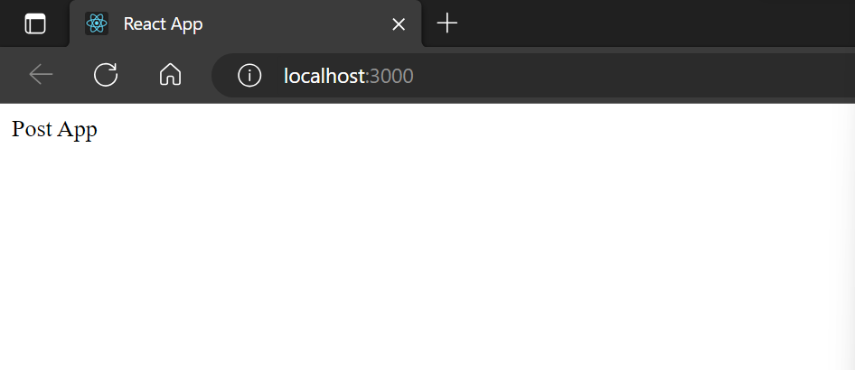

Create post

Alter: src/ App.js

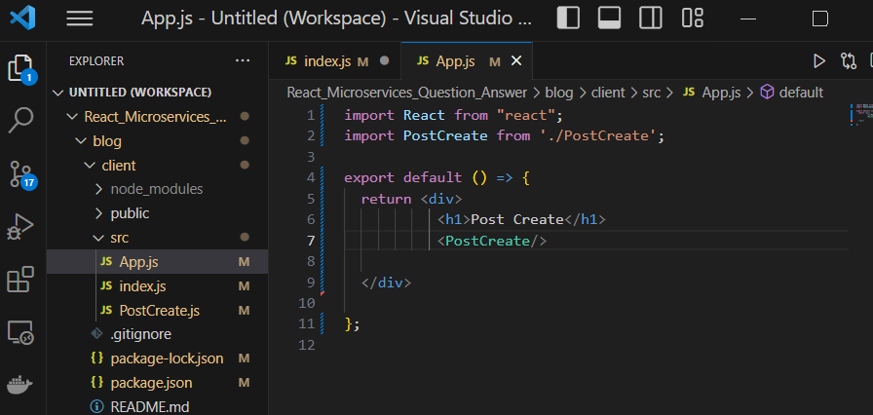

see: src/ index.js

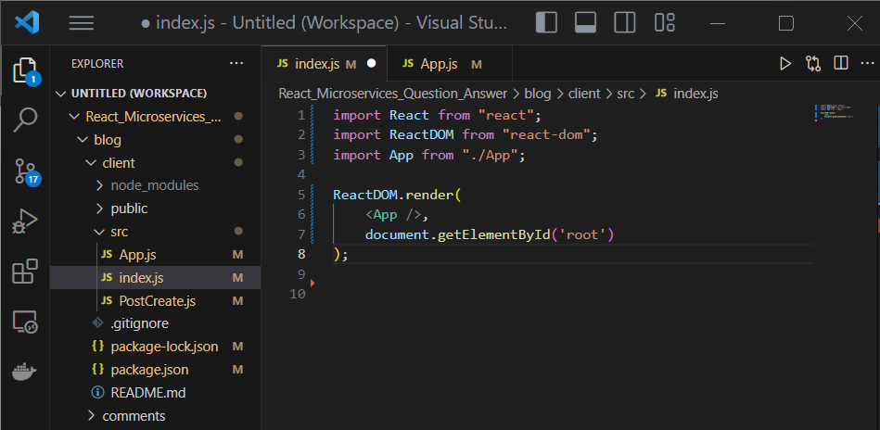

Create: src/ PostCreate.js

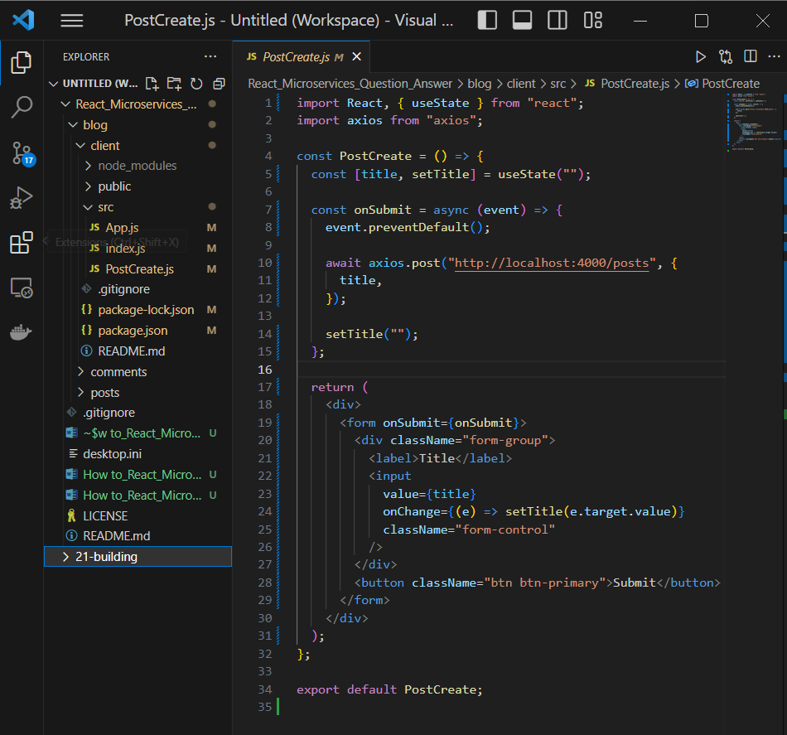

Open browser, return

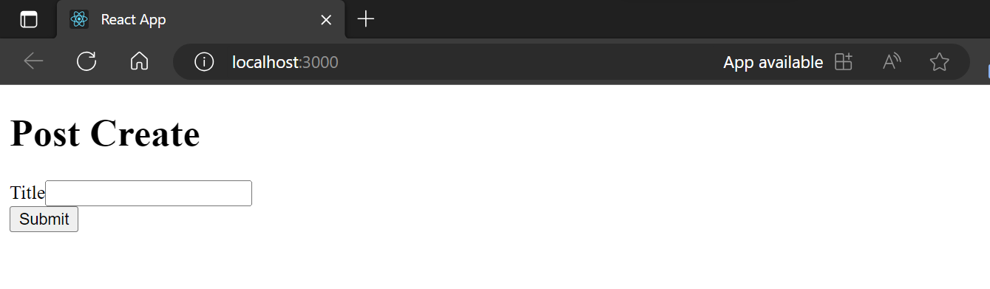

How to test, open React Development tool

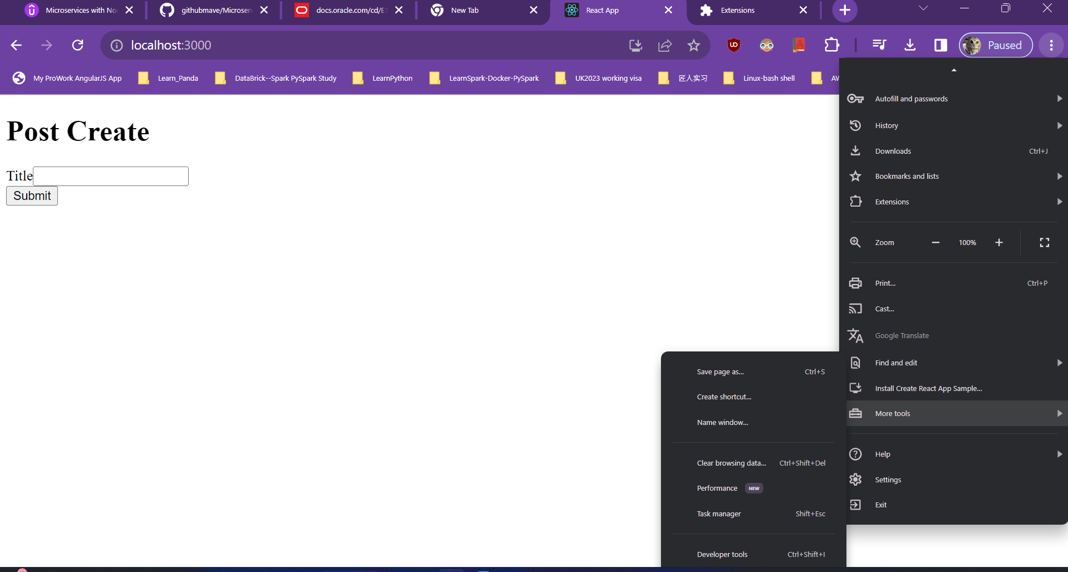

IMPORTANT: MUST HAVE react dev tool extension installed in Google/Chrome browser already

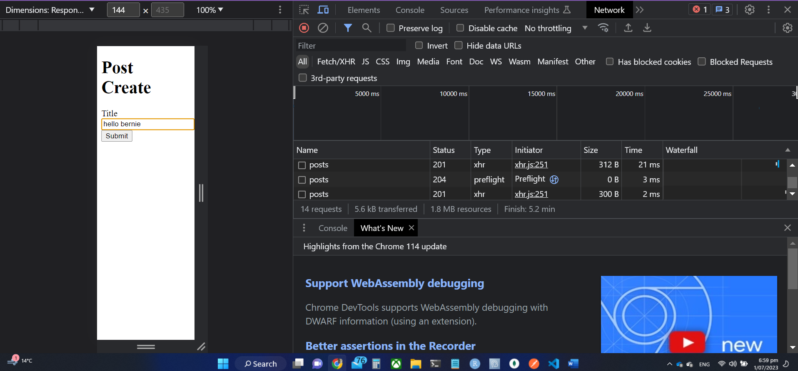

Top menu/ Network/

How to test?

Type “hello bernie” , then press Submit

There is not RED post on the right pane , should be OK

Press submit button, no result, WRONG

To fix

Go to. Blog/ posts/ run: npm install cors

And blog/ comments/ run; npm install cors

IN posts/index.js, alter: add …cors

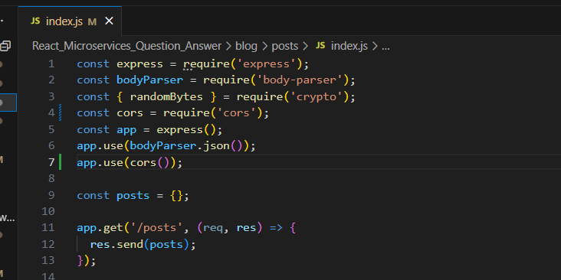

In comments/ index.js, alter: add cors***

Then,

Go to posts, run: npm start to turn on server

Go to comments, run npm start to turn on server

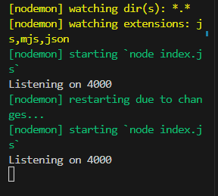

Create client/ src/ PostList.js

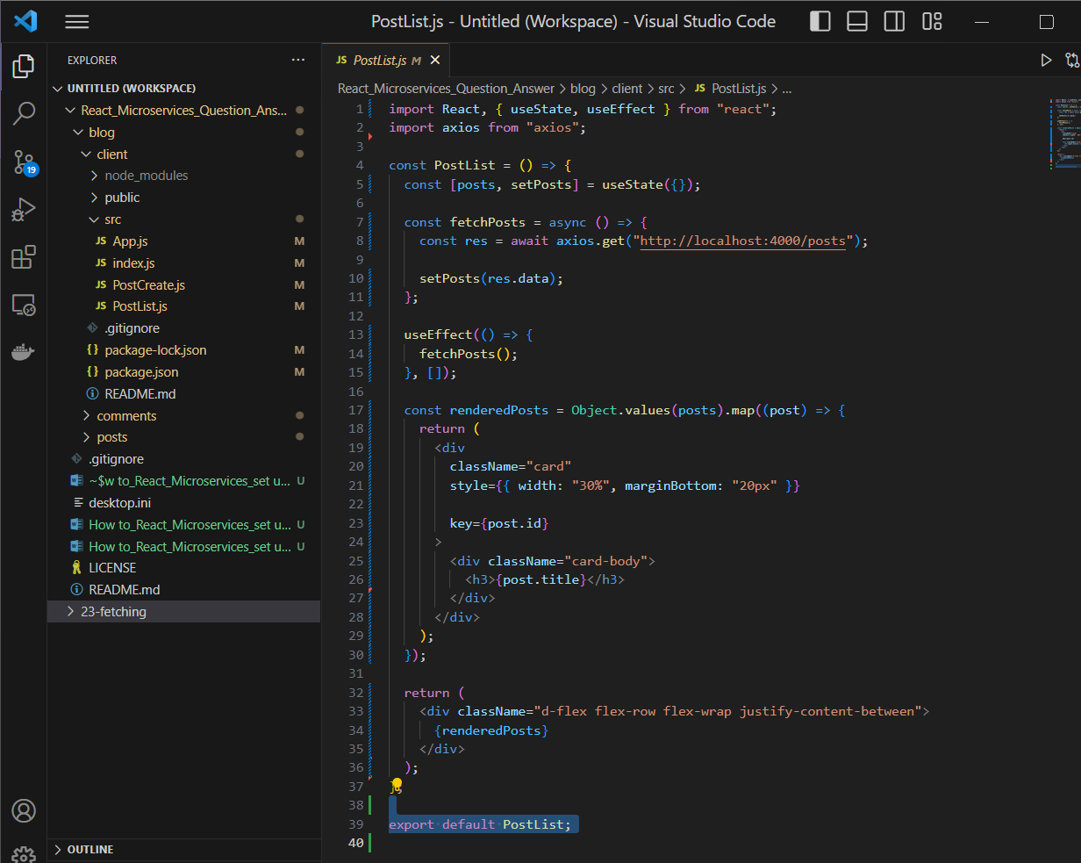

Then

Go to posts/ npm start

Go to comments/ npm start

Turn on two web servers

Then go to client / src/ npm start

Open up browser

After enter bernie, then: Return

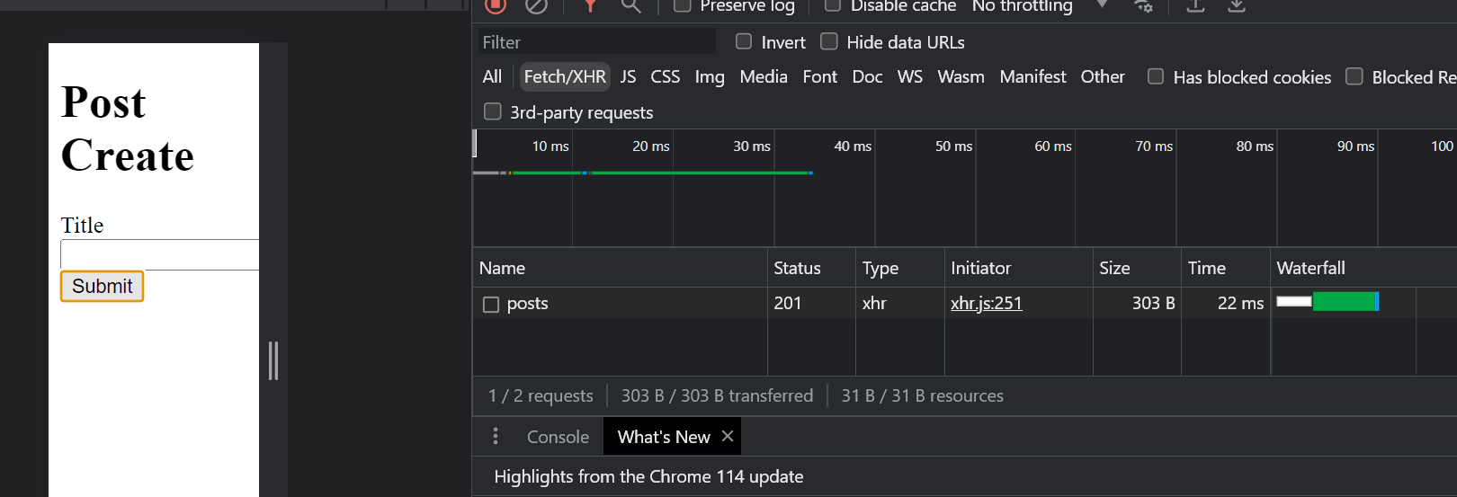

SUCCEEDED!

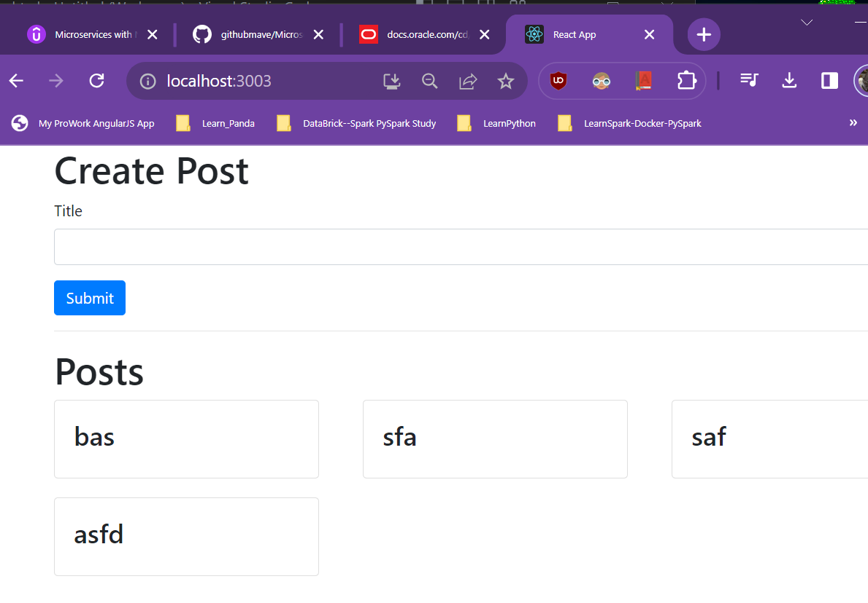

Create CommentCreate.js

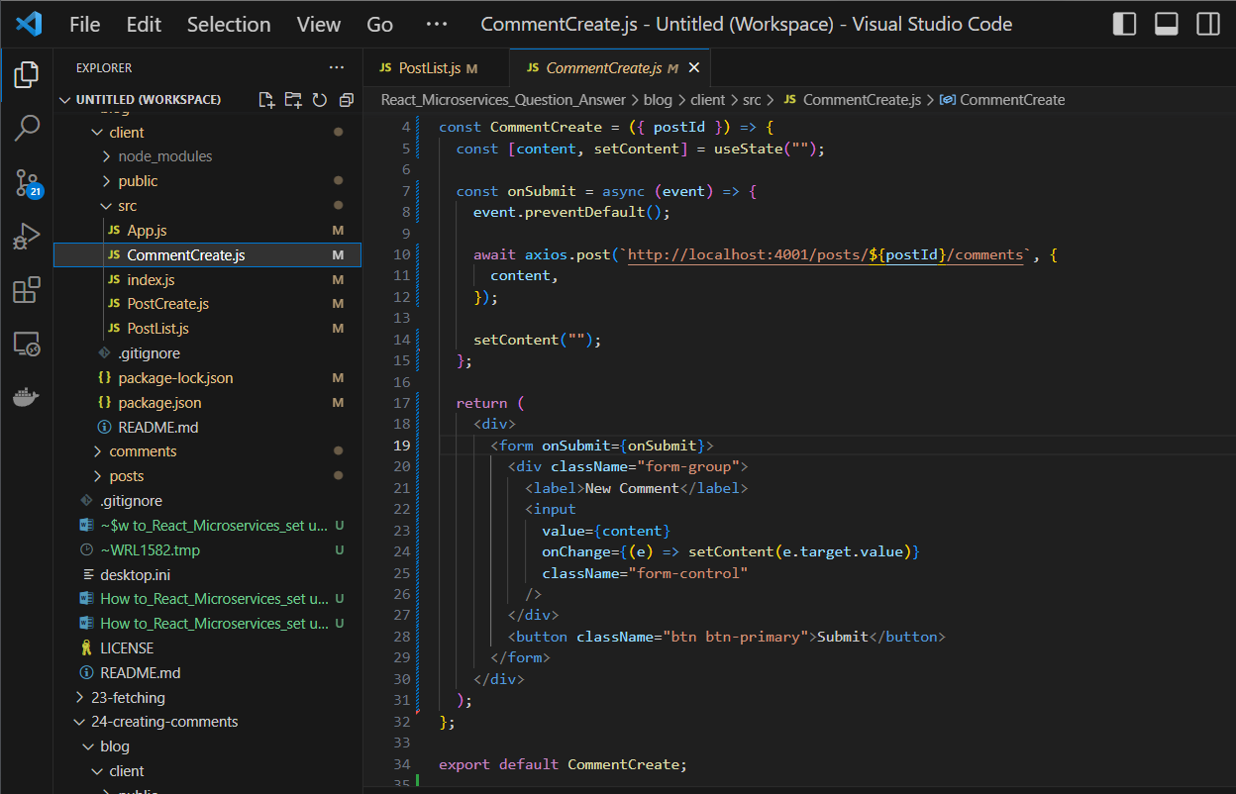

Add **commentdCreate.js** to PostList.js component

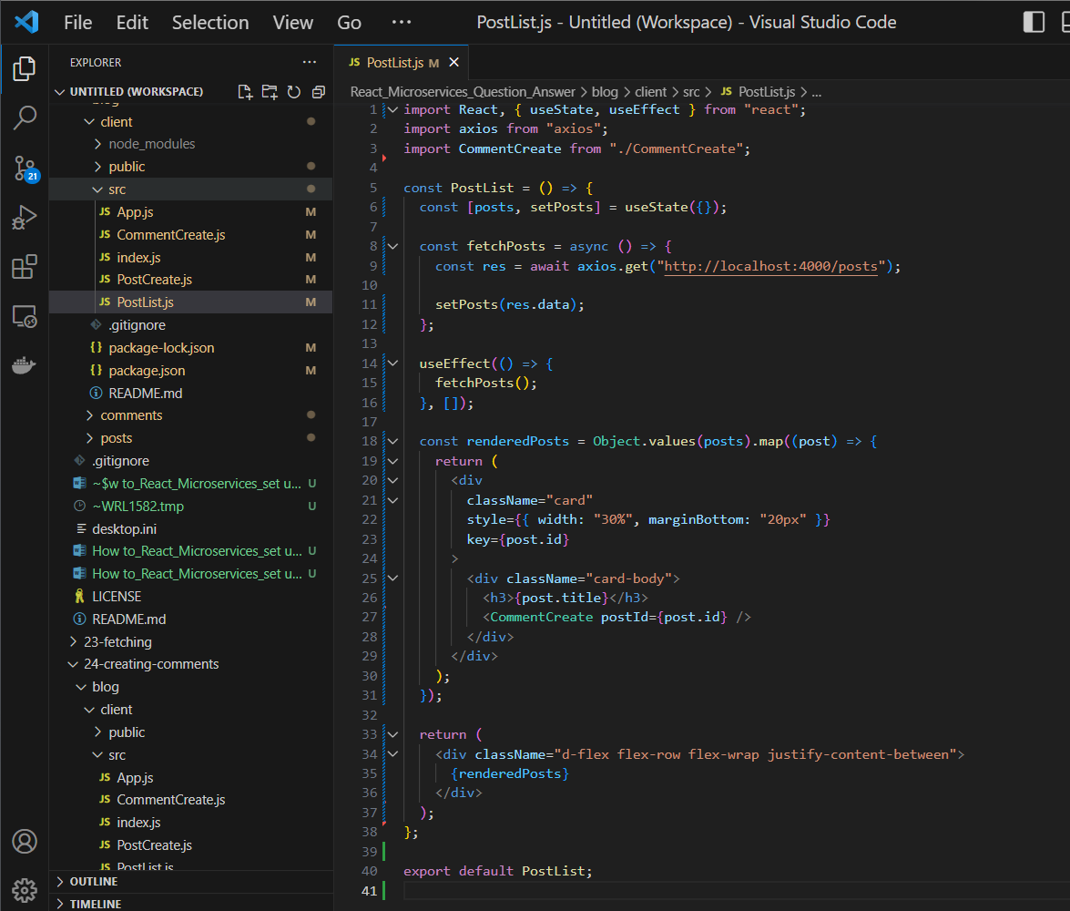

Go to blog/client/ npm start

Go to browser, return

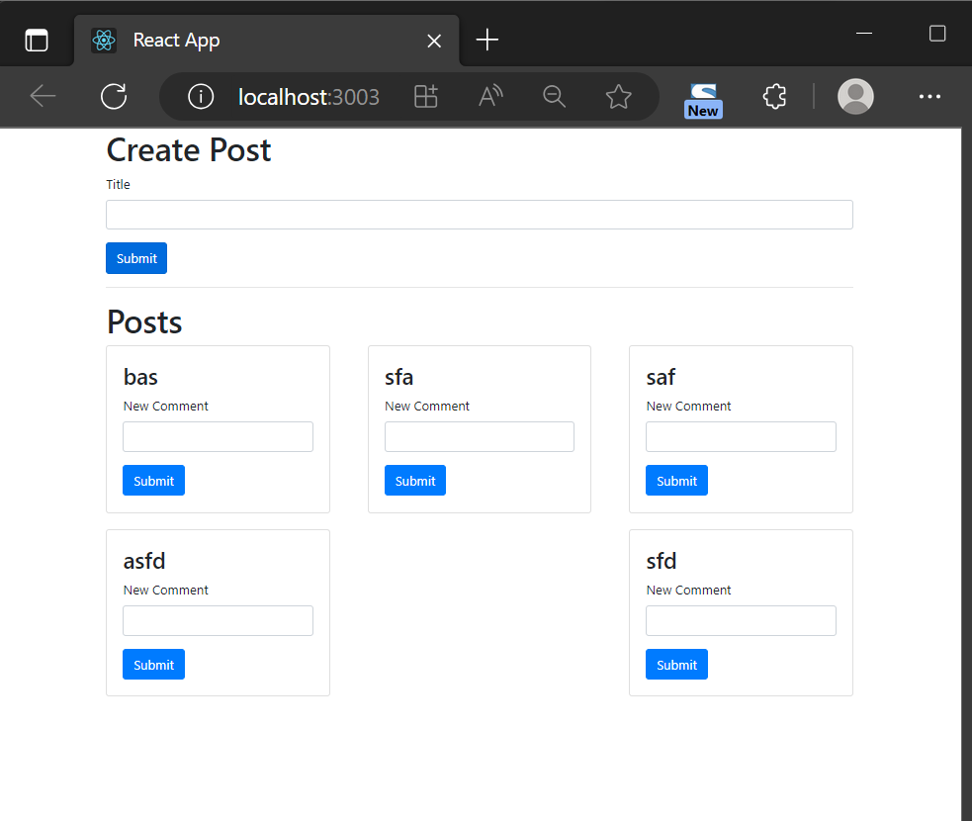

Create CommentList.js

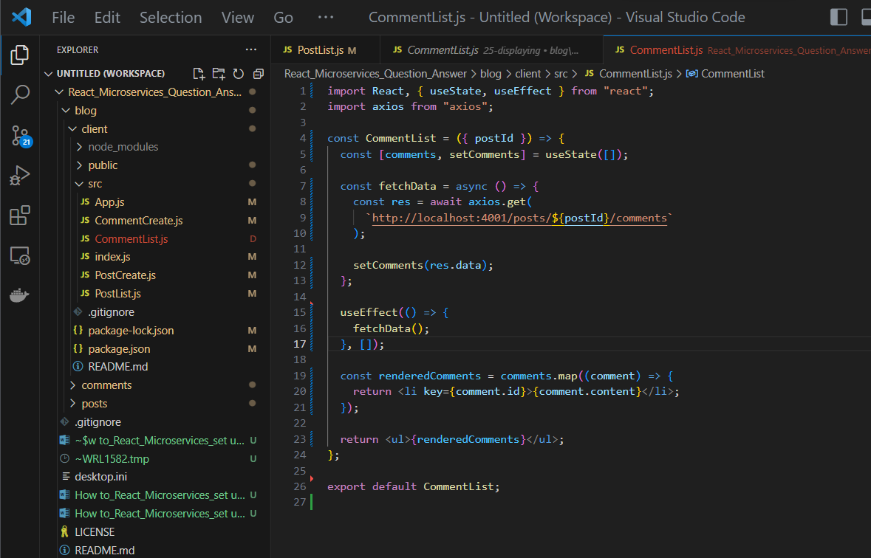

Add commentList.js onto PostList.js

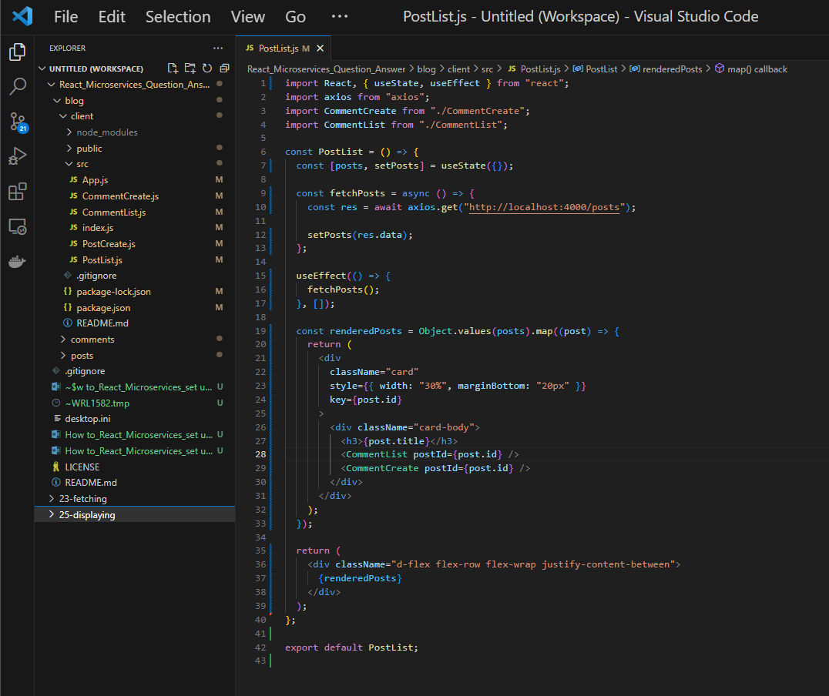

After add Post, postlist, comment, commentlist

RETURN:

